Student Name: Weight: 20%
Student ID: Marks: /120

Project: Implementing the FCFS Algorithm using Queues

Introduction
In this project, you’ll develop an implementation of the first-come, first-served (FCFS) scheduling algorithm using the queue data structure. FCFS, a non-pre-emptive algorithm, executes processes based on their arrival order. This project explores the intricacies of queue usage and its role in scheduling algorithms within operating systems, enriching your understanding of these concepts.

Objectives
Upon completing this project, you will have achieved the following objectives:
- Describe the FCFS scheduling algorithm’s importance in process management within operating systems.
- Implement a Process class to represent individual processes.
- Implement the QueueImplementation class using a single linked list approach, without relying on java.util.
- Simulate the FCFS algorithm by enqueuing processes and computing waiting and turnaround times.
- Calculate the average waiting time and the average turnaround time for a set of processes using the FCFS algorithm.
- Present process-specific waiting and turnaround times and the average waiting time and the average turnaround time.

Instructions
- Before you start:
- Review the class materials for modules 3 and 4.
- Complete the case exercises for those modules.
- If you need a refresher on the FCFS algorithm, see the Background Information session at the end of this document.
- This is a team assignment. Work in groups of three students.
- This project should take between six and nine hours, and you’re expected to complete it outside of scheduled hours.
- Ensure you follow the requirements outlined in the Restrictions section.
- Rigorously test your solution, as outlined in the Testing section.
- Refer to the Marking Criteria section for details on how you will be assessed.
- Refer to the Tips and Tricks section for guidance.
- In addition to writing the code, you are required to present your code to the instructor. Refer to the Code Presentation for further details.
- Individually, complete a Peer Assessment for your team. Review the Peer Assessment section below.
- Submit your completed assignment and Peer Assessment according to the date and time stated by your instructor to the Assignment submission area in Brightspace.

Guidelines
Follow these guidelines to complete your project.

Process Class
- Construct a Process class representing a process (the program in execution).
- Give each process the attributes: Process ID, Arrival Time, Burst Time.
- Develop constructors and methods aligned with the Process class’s purpose.

QueueImplementation Class
- Develop a QueueImplementation<T> class representing a queue.
- Design the queue using a single linked list-based approach, without leveraging the java.util package.
- Implement the following methods in the provided Queue Interface.zip file within the QueueImplementation class:
  - Enqueue: Adding an element to the queue.
  - Dequeue: Removing and returning the front element of the queue.
  - IsEmpty: Verifying if the queue is empty.
  - Clear: Removing all elements from the queue.

FCFSAlgorithm Class
- Construct an FCFSAlgorithm class simulating the FCFS scheduling algorithm via the Process and QueueImplementation classes.

Restrictions
- Organize your code solution into appropriate packages to promote a modular and structured approach.
- Adhere to provided instructions including class names, method signatures and requirements.
- Do not employ the java.util package for queue implementation.
- Implement the queue using a single linked list-based method.
- Integrate inline and multiple line comments in code snippets for clarity and comprehension.
- Use meaningful methods and variables names and make the code readable.
- Manage errors or exceptions that may arise during program execution.

Tips and Tricks
- Make sure you understand FCFS algorithm requirements before you start on your implementation.
- Outline class structures and data flow before you start coding.
- Tackle smaller subproblems individually before integrating them into main classes.
- Test each component independently before combining them into the FCFSAlgorithm class.
- Use descriptive variable and method names.
- Provide clear comments to clarify code functionality.
- Debug and resolve errors you encounter during testing.
- Consult external resources, such as those in the Resources section to deepen your understanding of FCFS.

Code Presentation
In addition to developing your code, you'll have the opportunity to present your project to the instructor, providing insights into your coding process and project implementation. The presentation should encompass the following key aspects.
- Explain the problem that the code is addressing.
- Describe any challenges or constraints the team faced during development.
- Present the high-level architecture of the project and the role of each team member.
- Explain the code's structure, organization, and FCFS significant algorithm and data structures used.
- Show how the code works in action using the given sample run.
- Discuss the testing strategies employed by the team, including unit tests, integration tests, and user acceptance testing.

Peer Assessment
Each team member must complete a peer assessment of their group members and submit it with the same title as the “Your Name_AssignmentName/ProjectName”. The purpose of this peer review is to offer constructive feedback to your peers. Please utilize the template provided below to assign ratings to each of your group members on a scale of 1 to 3, where:
- 1 = Significant area for improvement
- 2 = Acceptable but with some areas for improvement
- 3 = Excellent contribution
 | <Name 1> | <Name 2> | <Name 3> | <Name 4>
Motivation and engagement in assignment | /3 | /3 | /3 | /3
Timely submission of deliverables | /3 | /3 | /3 | /3
Effective communication and problem solving | /3 | /3 | /3 | /3
Other comments for your peers

Testing
Conduct comprehensive testing according to the provided sample runs below, ensuring that you produce the results you expected.
Note: User inputs are bold and underlined.

Sample Run 1
When your program begins, it should display a JOptionPane prompt asking you to press OK to initiate the simulation!
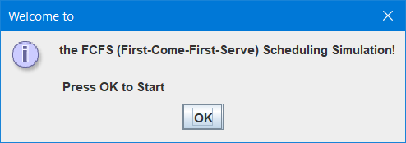

After pressing 'OK,' your program should commence gathering the following information from you:

Enter the number of processes ► 5
Enter arrival time for process 1 ► 0
Enter burst time for process 1 ► 4
Enter arrival time for process 2 ► 1
Enter burst time for process 2 ► 3
Enter arrival time for process 3 ► 2
Enter burst time for process 3 ► 2
Enter arrival time for process 4 ► 3
Enter burst time for process 4 ► 6
Enter arrival time for process 5 ► 4
Enter burst time for process 5 ► 5

In doing so, your program should present the results as follows in a JOptionPane:

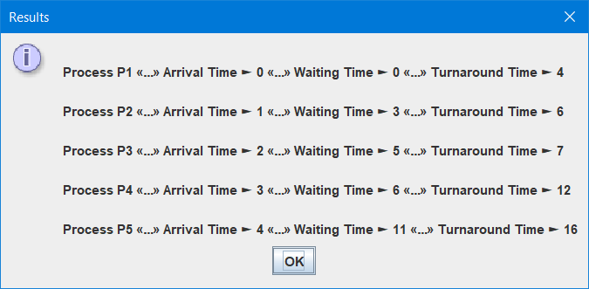
After pressing 'OK,' it should display the average results in the JOptionPane as follows:

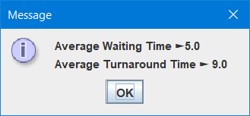

Sample Run 2
When your program begins, it should display a JOptionPane prompt asking you to press OK to initiate the simulation!



After pressing 'OK,' your program should commence gathering the following information from you:

Enter the number of processes ► 10
Enter arrival time for process P1 ► 0
Enter burst time for process P1 ► 4
Enter arrival time for process P2 ► 1
Enter burst time for process P2 ► 3
Enter arrival time for process P3 ► 2
Enter burst time for process P3 ► 2
Enter arrival time for process P4 ► 3
Enter burst time for process P4 ► 6
Enter arrival time for process P5 ► 4
Enter burst time for process P5 ► 5
Enter arrival time for process P6 ► 5
Enter burst time for process P6 ► 7
Enter arrival time for process P7 ► 6
Enter burst time for process P7 ► 5
Enter arrival time for process P8 ► 7
Enter burst time for process P8 ► 7
Enter arrival time for process P9 ► 8
Enter burst time for process P9 ► 8
Enter arrival time for process P10 ► 9
Enter burst time for process P10 ► 10

In doing so, your program should present the results as follows in a JOptionPane:
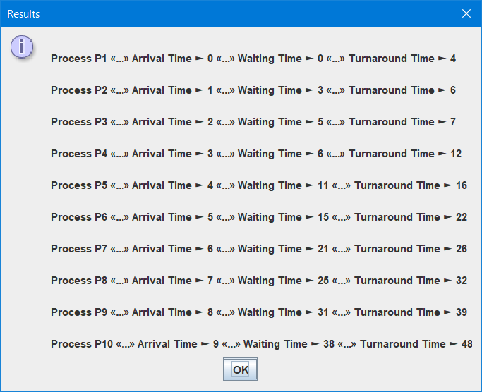
After pressing 'OK,' it should display the average results in the JOptionPane as follows:

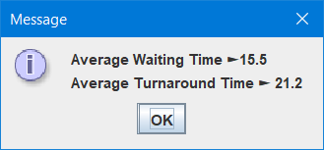

Submission Requirements
Ensure that your submission is well organized by following these guidelines.
- Create a JAR file: Compile your Java program into a JAR file containing source code, compiled classes and necessary resources.
- Assemble a ZIP archive: Group all required files into a single ZIP archive.
  - Include the JAR file: Place the JAR file containing your Java program inside the ZIP archive, ensuring it includes all necessary dependencies.
  - Add a readme file: Include a concise readme file detailing how to run your program.
  - Organize your ZIP archive: Arrange files in a structured manner within the ZIP archive by considering separate packages for file types.

Background Information: First-Come, First-Served (FCFS) Algorithm Explanation
The FCFS algorithm is non-pre-emptive and executes processes in the order of their arrival. The first process to arrive is the first to execute. To analyze the performance of the algorithm, you need to calculate waiting and turnaround times for each process and the average waiting time and the average turnaround time. Do a search or use the provided textbook in the Resources section for more information about the algorithm and for calculating the waiting and turnaround times.
Doing so, practice with the following predefined dataset: five processes (P1, P2, P3, P4, and P5) and the arrival time and burst time (time needed from CPU to execute its instructions) for each one:
Process ID | Arrival Time | Burst Time
P1 | 0 | 4
P2 | 1 | 3
P3 | 2 | 2
P4 | 3 | 6
P5 | 4 | 5

Use this dataset and calculate the waiting and turnaround times for each process and the average waiting time and the average turnaround time and add them to the following table:
 | Waiting time | Turnaround time
P1
P2
P3
P4
P5
Average

Double check your calculations by consulting the first sample run.

Resources
- Chapter 3: Processes in Silberschatz, A., Galvin, P. B., and Gagne, G. (2018). Operating System Concepts. (10th ed.). Wiley.

Student Code of Conduct
Academic dishonesty is considered to be an extremely serious academic offense. Reference Procedure AC. 3.4.1 – Student Code of Conduct (available on http://www.sait.ca).
Be prepared to share an explanation of your solutions. Your instructor may select any team to provide an explanation to any question.

Marking Criteria
Criteria | Needs Improvement | Good | Excellent | Marks
Process class | Incomplete or incorrect implementation of the Process class. Missing or improperly defined attributes and methods. (3 marks) | Adequate implementation of the Process class with correct attributes and methods. (6 marks) | Comprehensive and accurate implementation of the Process class, demonstrating a clear understanding of attributes and methods. (10 marks) | /10
QueueImplementation class without using java.util | Incomplete or erroneous implementation of the QueueImplementation class. Lacks necessary methods or improper queue management. (6 marks) | Competent implementation of the QueueImplementation class, demonstrating functional queue operations. (12 marks) | Comprehensive and accurate implementation of the QueueImplementation class, showcasing effective use of single linked list-based approach for queue management. (20 marks) | /20
FCFSAlgorithm class | Incomplete or flawed implementation of the FCFSAlgorithm class. Limited or incorrect simulation of the FCFS algorithm. (9 marks) | Proficient implementation of the FCFSAlgorithm class, demonstrating effective simulation of the FCFS algorithm with minor issues. (18 marks) | Comprehensive and accurate implementation of the FCFSAlgorithm class, showcasing a clear understanding of the FCFS algorithm and its simulation. (30 marks) | /30
Process Creation | Inadequate creation of processes. Arrival time and burst times not managed correctly. (6 marks) | Competent creation of processes, ensuring proper assignment of arrival time and burst times. (9 marks) | Skillful creation of processes, accurately assigning arrival time and burst times according to specifications. (15 marks) | /15
Display Accuracy | Inadequate or incorrect display of arrival time, waiting time, turnaround time, average waiting time, or average turnaround time. (6 marks) | Competent display of arrival time, waiting time, turnaround time, average waiting time, or average turnaround time with minor discrepancies. (9 marks) | Clear and organized display of arrival time, waiting time, turnaround time, and accurate average waiting time and average turnaround time. (15 marks) | /15
Code Organization and Readability | Poor code organization and readability. Lack of comments or meaningful variable names. Disregard for conventions. (3 marks) | Well-structured and readable code with appropriate comments and variable names. Adherence to coding conventions. (6 marks) | Exceptional code organization and readability. Comprehensive comments, descriptive variable names, and strict adherence to coding conventions. (10 marks) | /10
Code Presentation | Limited or unclear explanation of the problem, challenges, and project architecture. (6 marks) | Provides a clear explanation of the problem, challenges, and project architecture. (12 marks) | Presents a compelling and engaging overview, covering all aspects effectively. (20 marks) | /17
Total |  |  |  | /117

Final Individual Marks
Team Total (up to 117) | x | Peer Evaluation Multiplier (as a percentage) | = | Total
 | x |  | =
 |  |  |  | +
Peer Evaluations Completed (3)
 |  |  |  | =
Final Individual Marks |  |  |  | /120

